**DAILY ONLINE ACTIVITIES SUMMARY**

|  |  |  |  |  |  |  |  |  |
| --- | --- | --- | --- | --- | --- | --- | --- | --- |
| **Date:** | **19/06/2020** | | | | | **Name:** | **PRANEETA P HANDRAL** | |
| **Sem & Sec** | **4​th​ SEM. & ‘B’ SEC.** | | | | | **USN:** | **4AL19CS401** | |
| **Online Test Summary** | | | | | | | | |
| **Subject** | | **MICRO-CONTROLLER AND EMBEDDED SYSTEMS** | | | | | | |
| **Max. Marks** | | **20** | | **Score** | | | **9** | |
| **Certification Course Summary** | | | | | | | | |
| **Course** | **Blockchain Essentials** | | | | | | | |
| **Certificate Provider** | | | **Cognitive class** | | **Duration** | | | **6 Hrs.** |
| **Coding Challenges** | | | | | | | | |
| **Problem Statement:** **Write a C Program to Count total set bits in all numbers from 1 to n.**  **Problem Statement:** **Write a C Program to rotate a Matrix by 90 Degree in Clockwise or Anticlockwise Direction.** | | | | | | | | |
| **Status:** **Executed.** | | | | | | | | |
| **Uploaded the report in Github** | | | | | **Yes** | | | |
| **If yes Repository name** | | | | | **LockdownCoding**  <https://github.com/praneetahandral/lockdowncoding> | | | |
| **Uploaded the report in slack** | | | | | **Yes** | | | |

**Online Test Summary: 18CS44 test was scheduled from 03:00 pm to 03:30 pm. The portion for the IA was 4th module there were 20 questions and the time assigned was 30 minutes the questions were mcq type. There were 20 questions of 1 marks respectively**.

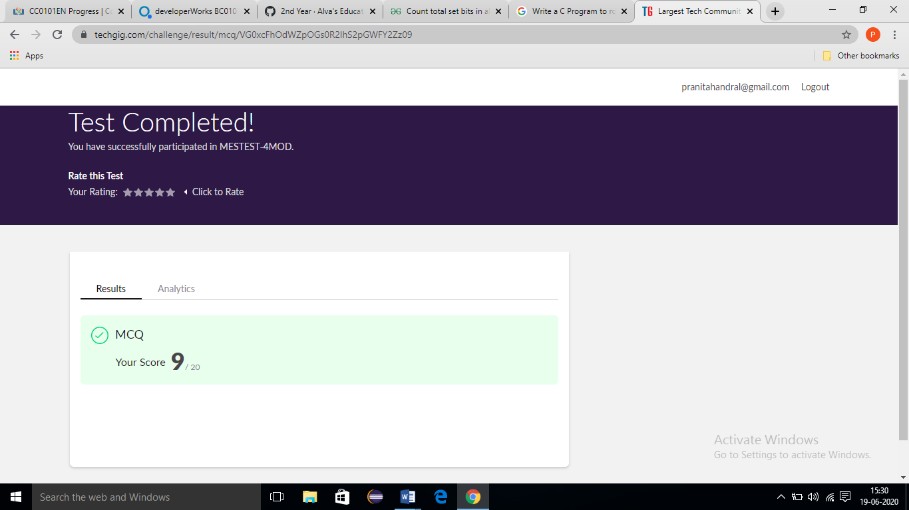

**Online Certification course Summary​:** I have taken my Online Certification Course in **Cognitive class**  the course which I have opted is **Blockchain Essentials**. Course contains videos, tutorials, assessments and quiz. Today I have gone **blockchain asset transfer** and **blockchain asset transfer** And also **Putting concepts into practice with an end-to-end demo.**

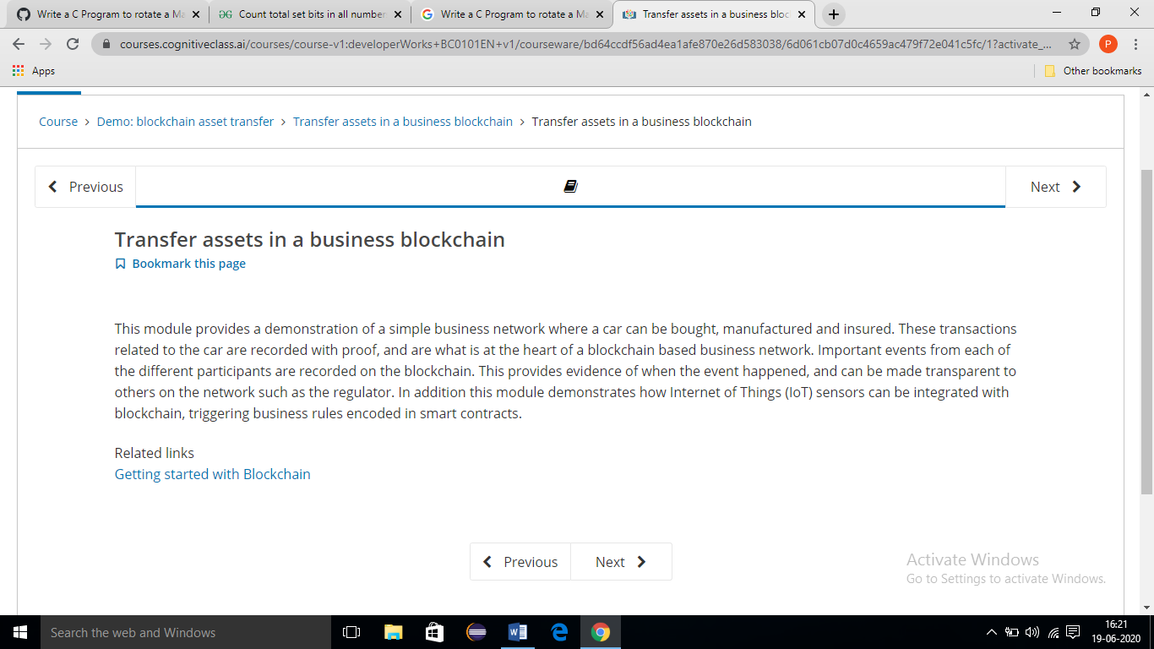

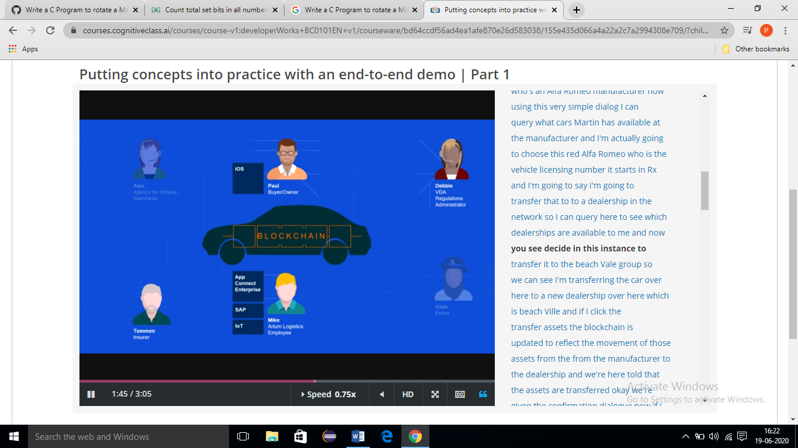

**Online Coding Summary​:** Today I received Two programs one from prof. Venkatesh CSE Dept. and another one from prof. Shilpa CSE Dept. I have written one program and uploaded it to my Github repository. This is my repository snapshot. I have uploaded the frequency program.

